how-to-organize-your-wedding-in-marrakech

How to organize your wedding in Marrakech?
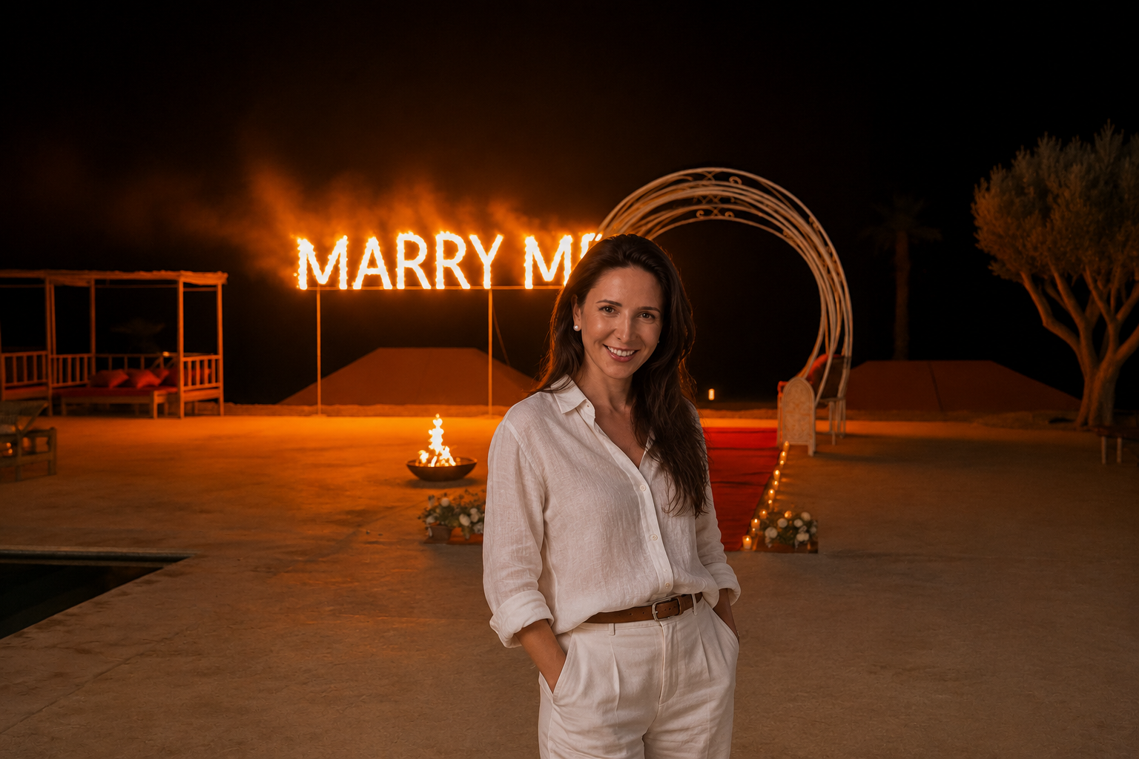 Erica,September 7th, 2022

How to Organize Your Wedding in Marrakech?

The Ultimate Guide to Planning a Luxury Destination Wedding in Marrakech
By Marrakech Proposal
Marrakech has become one of the world’s most sought-after destinations for couples dreaming of an unforgettable wedding abroad. With its breathtaking palaces, luxury riads, desert landscapes, vibrant souks, refined hospitality, and year-round sunshine, the Red City offers the perfect setting for a romantic and immersive destination wedding experience.
From intimate elopements to extravagant multi-day celebrations, organizing a wedding in Marrakech combines elegance, culture, adventure, and timeless beauty. But planning a destination wedding in Morocco also requires local expertise, careful coordination, and a clear vision to ensure every detail flows seamlessly.
In this guide, Marrakech Proposal shares the most important steps and insider tips to help you organize your dream wedding in Marrakech.

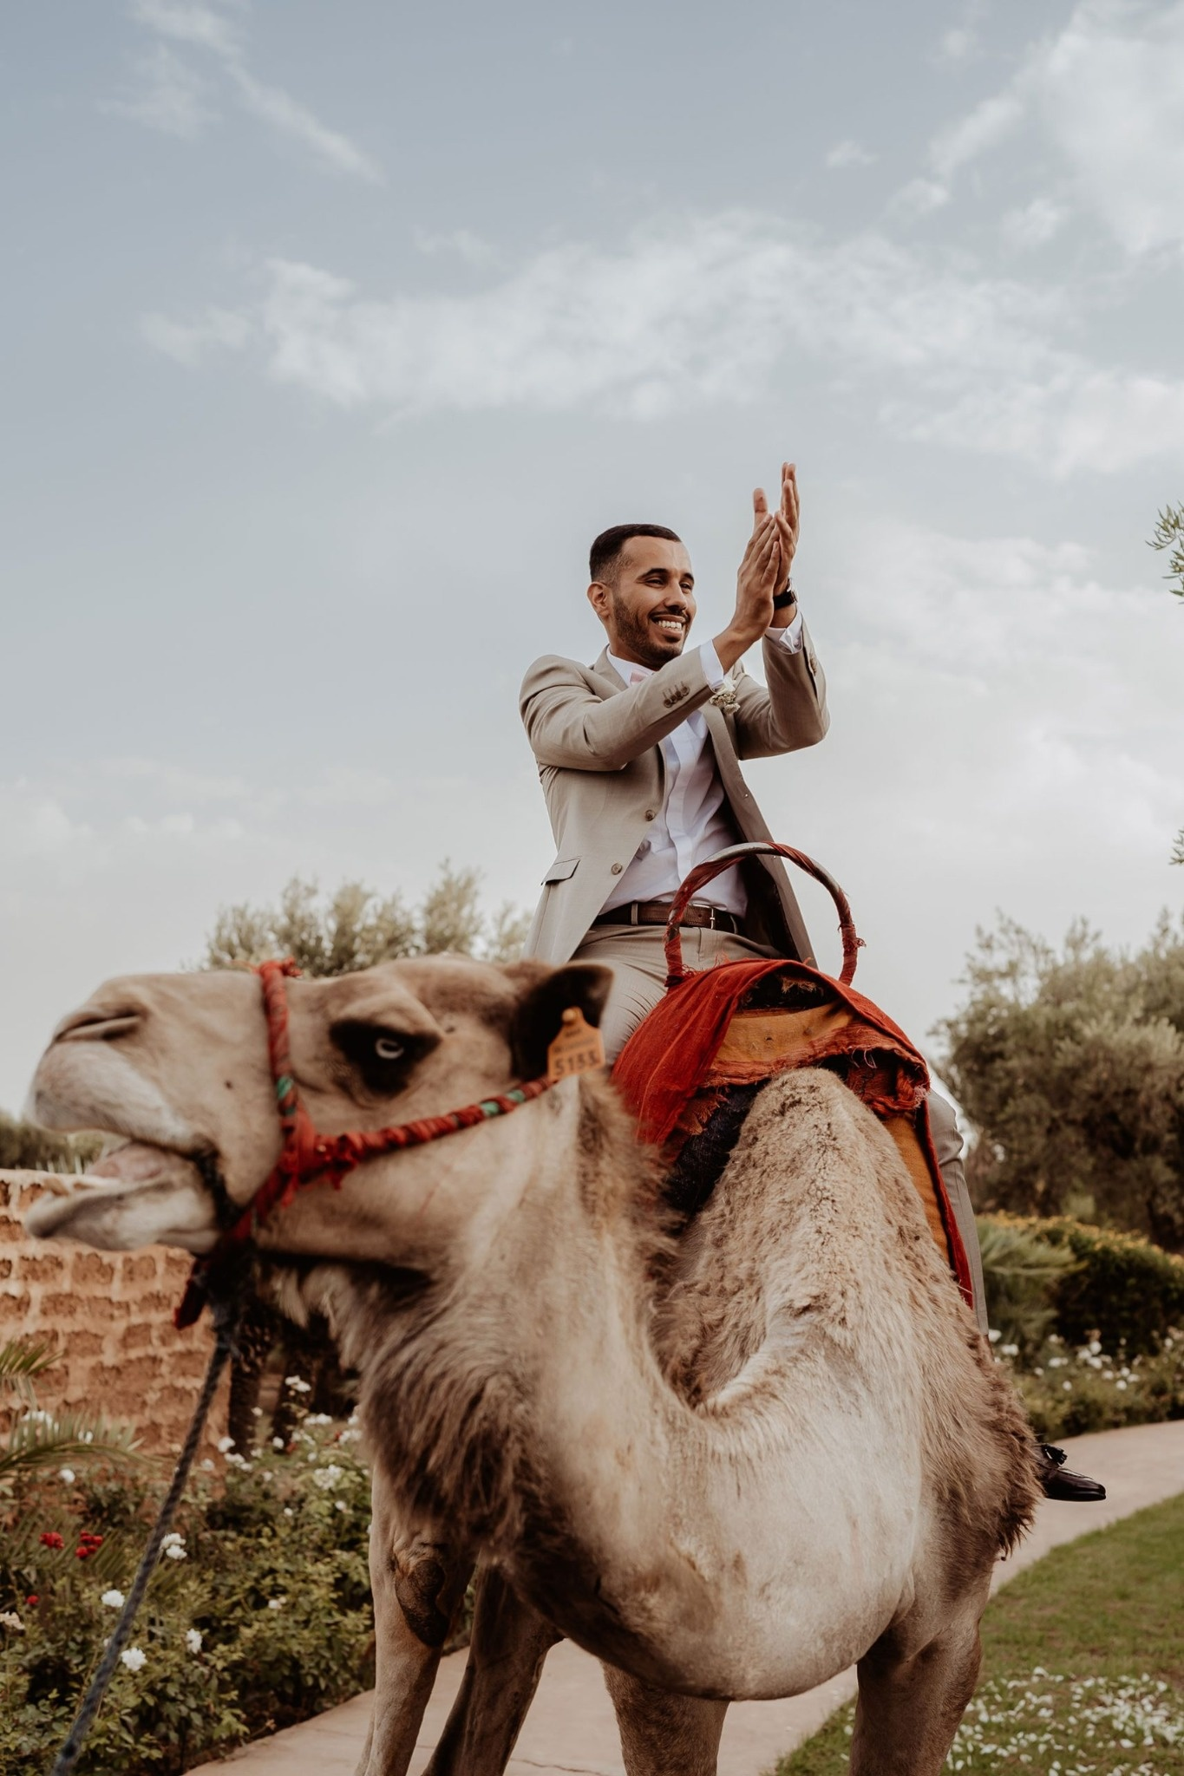

Why Choose Marrakech for Your Destination Wedding?
Marrakech offers something truly unique: a perfect balance between luxury, authenticity, and unforgettable experiences.
Whether you imagine:
- a candlelit desert wedding in Agafay,
- a romantic riad ceremony in the Medina,
- a luxury villa wedding surrounded by palms,
- or a multi-day celebration in a Moroccan palace,
Marrakech provides extraordinary venues and magical atmospheres unlike anywhere else in the world.
Couples also choose Marrakech because of:
- the warm climate and beautiful sunsets,
- luxury accommodations at competitive prices,
- direct international flight connections,
- rich Moroccan culture and hospitality,
- unforgettable guest experiences beyond the wedding day.
A destination wedding in Marrakech is not just a ceremony — it becomes a complete travel and emotional experience shared with your loved ones.

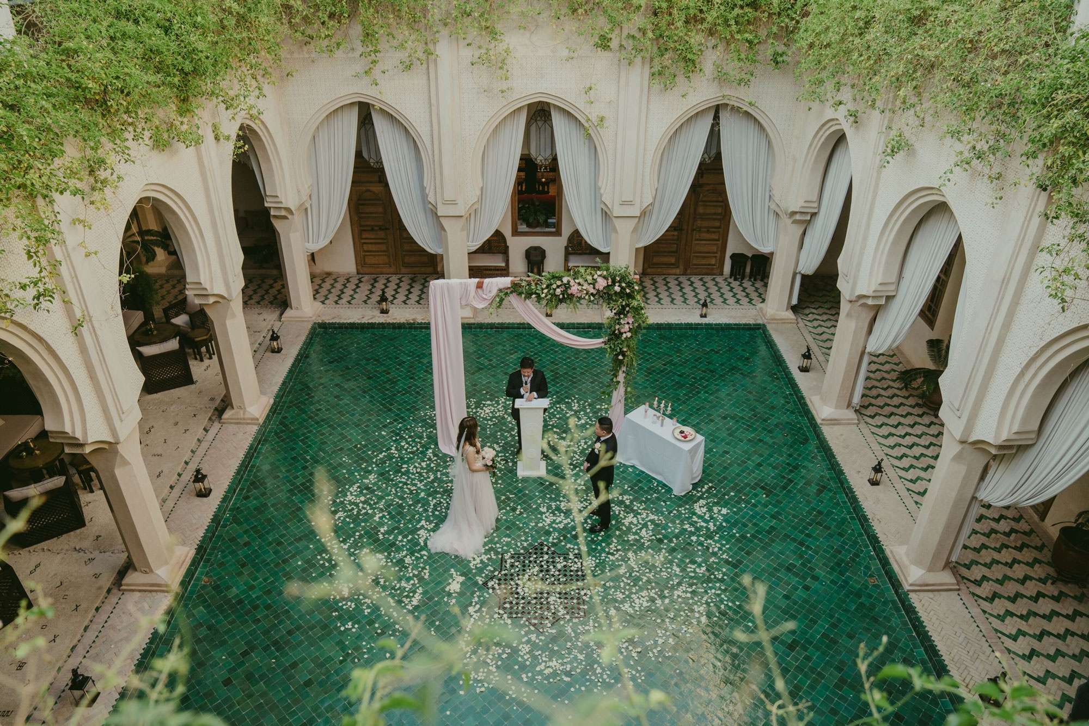

Start Planning Your Marrakech Wedding Early
One of the biggest mistakes couples make when planning a wedding in Marrakech is underestimating how quickly luxury venues book up — especially during high season.
The best periods for destination weddings in Marrakech are generally:
- March to May
- September to early November
Luxury riads, villas, palaces, photographers, caterers, and entertainment vendors can be fully booked many months — sometimes over a year — in advance.
Starting early allows you to:
- secure the best wedding venues in Marrakech,
- compare options calmly,
- optimize your wedding budget,
- organize guest logistics properly,
- and enjoy the planning process stress-free.

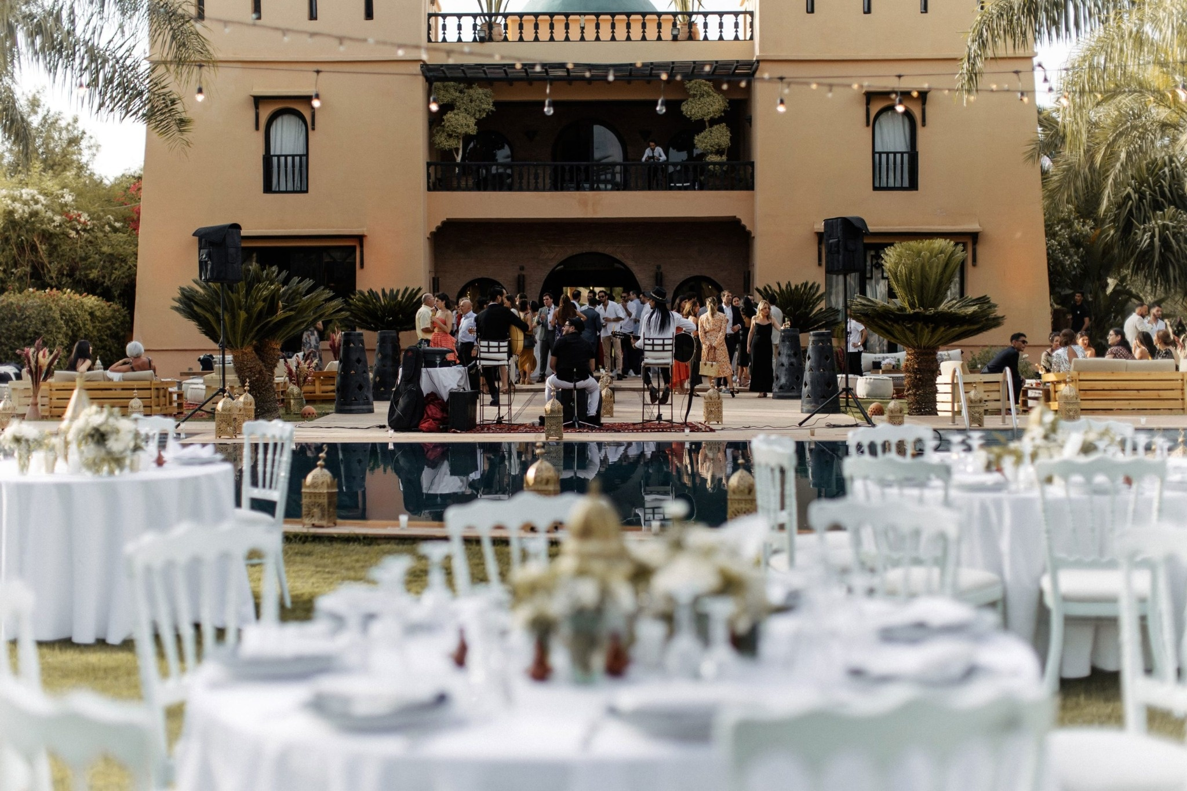

Define Your Wedding Vision & Guest Experience
Before choosing venues or décor, it’s important to define the overall atmosphere and experience you want to create.
Ask yourself:
- Do you prefer an intimate elopement or a large destination wedding?
- Are you dreaming of a modern luxury wedding or something more traditional and authentic?
- Would you like a one-day celebration or a multi-day wedding experience?
- Do you want to include Moroccan cultural elements?
- What emotions do you want your guests to feel?
In Marrakech, weddings often become immersive experiences that go beyond the ceremony itself:
- welcome dinners,
- pool parties,
- desert experiences,
- traditional entertainment,
- spa retreats,
- guided souk tours,
- Moroccan dinners under the stars.
The guest experience becomes part of the magic.

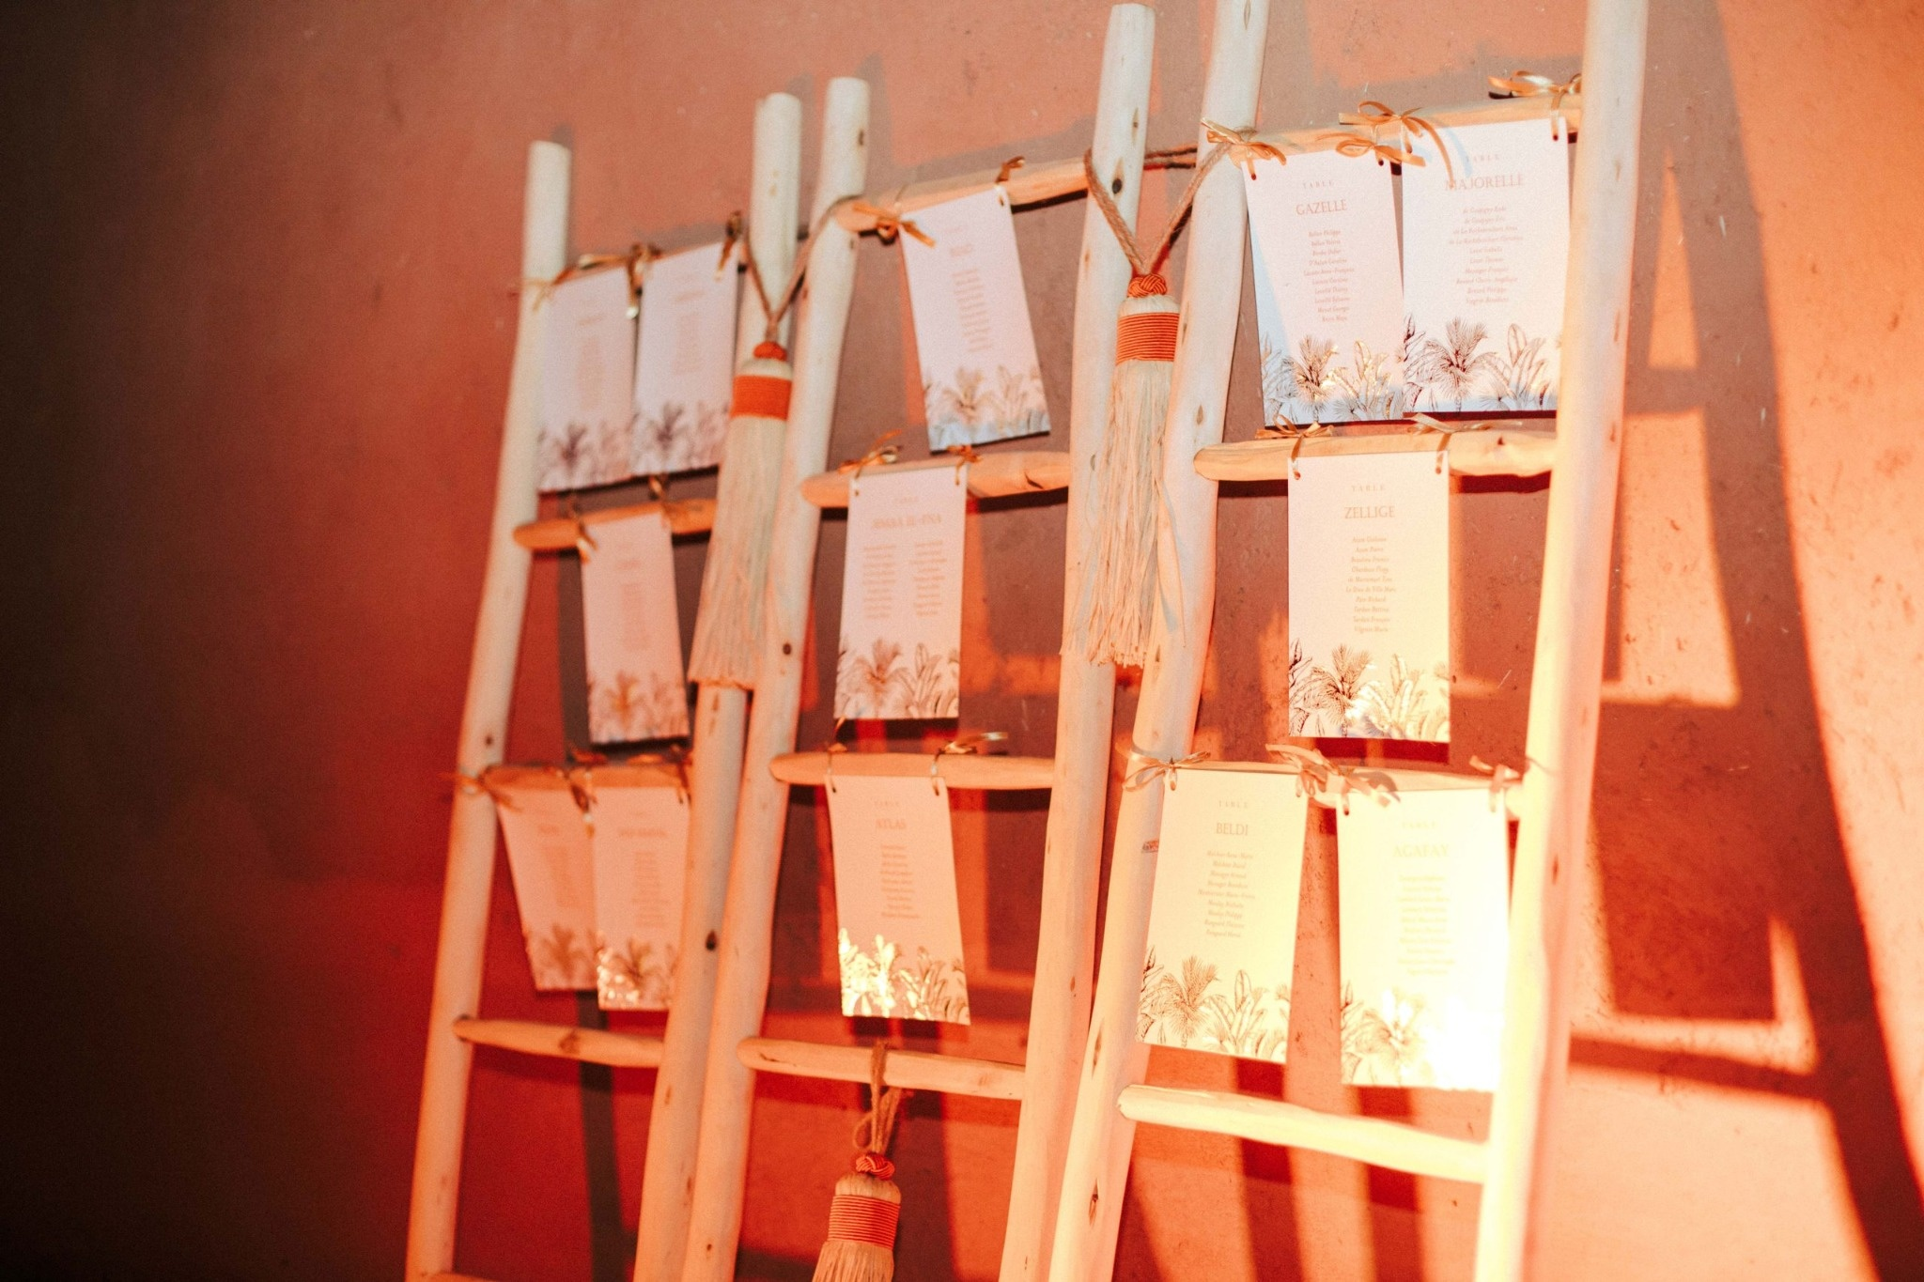

Choosing the Perfect Wedding Venue in Marrakech
Your venue is the foundation of your entire wedding design and guest experience.
Marrakech offers an incredible variety of wedding venues:
- luxury palaces,
- traditional riads,
- private villas,
- desert camps,
- boutique hotels,
- olive grove estates,
- rooftop terraces,
- and garden venues.
Each venue offers a completely different atmosphere and logistical structure.
When selecting your wedding venue in Marrakech, important factors include:
- accommodation capacity,
- privacy and exclusivity,
- accessibility,
- noise restrictions,
- catering possibilities,
- backup plans for weather,
- ceremony and dinner flow,
- technical setup possibilities,
- and guest comfort.
This is where working with an experienced Marrakech wedding planner becomes essential. Local expertise helps avoid hidden logistical challenges and ensures the venue truly matches your vision and expectations.

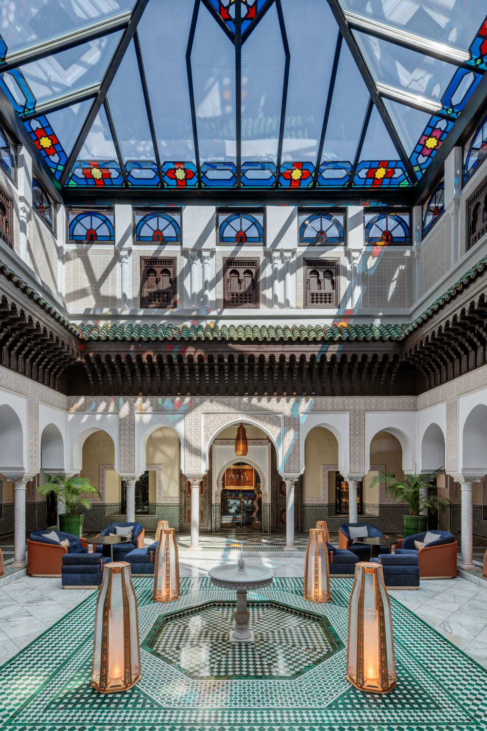

Planning Your Wedding Budget in Marrakech
One of the advantages of organizing a wedding in Morocco is the flexibility in styles and budgets.
Whether you want:
- an intimate luxury elopement,
- a chic destination wedding,
- or an extravagant multi-day celebration,
Marrakech can adapt beautifully to different levels of luxury and production.
Your wedding budget should generally include:
- venue & accommodation,
- catering & beverages,
- wedding planner,
- décor & florals,
- photography & videography,
- entertainment,
- lighting & sound,
- transportation,
- beauty services,
- stationery,
- guest experiences,
- and contingency expenses.
A professional wedding planner in Marrakech helps prioritize investments intelligently while keeping the experience elegant and cohesive.

Organizing Guest Logistics for a Destination Wedding
Guest management is one of the most important aspects of a destination wedding in Marrakech.
Your guests may be traveling internationally, often discovering Morocco for the first time. Clear communication and thoughtful organization will elevate their experience significantly.
Key elements include:
- accommodation management,
- airport transfers,
- wedding schedules,
- local recommendations,
- transportation between venues,
- welcome gifts,
- dress code guidance,
- and activity suggestions.
Many couples also create personalized welcome experiences with Moroccan touches such as:
- traditional pastries,
- local tea ceremonies,
- handcrafted gifts,
- live music,
- or custom itineraries.
The goal is to make guests feel welcomed, comfortable, and immersed in the beauty of Marrakech from the moment they arrive.
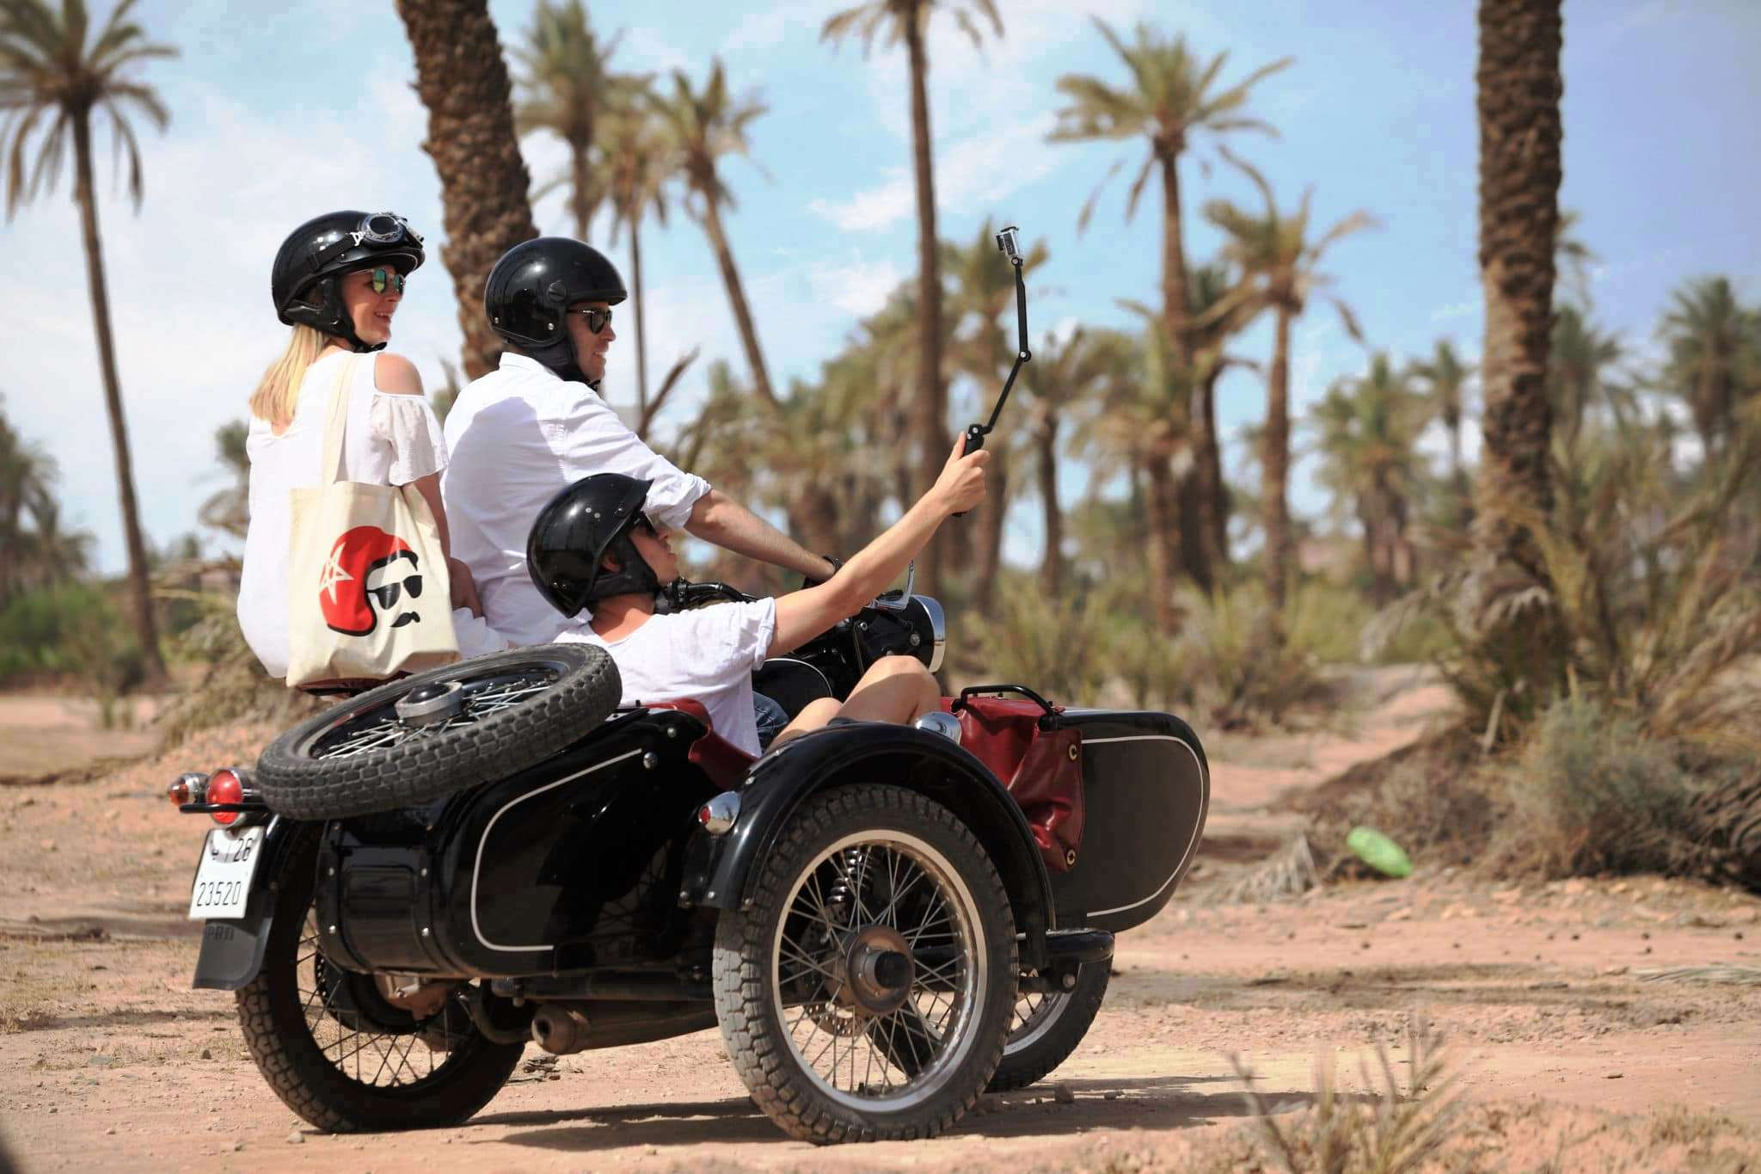

Work with Trusted Local Wedding Vendors
Building the right vendor team is essential for a successful destination wedding in Marrakech.
An experienced local wedding planner gives you access to:
- trusted photographers,
- videographers,
- florists,
- caterers,
- live musicians,
- DJs,
- makeup artists,
- transportation teams,
- lighting & sound technicians,
- entertainers,
- and production specialists.
Local expertise is particularly important in Morocco because logistics, timing, communication styles, and technical execution can vary significantly depending on the venue and suppliers.
At Marrakech Proposal, we carefully curate every supplier according to:
- your style,
- your guest count,
- your priorities,
- your budget,
- and the overall wedding atmosphere you want to create.
Every detail matters.

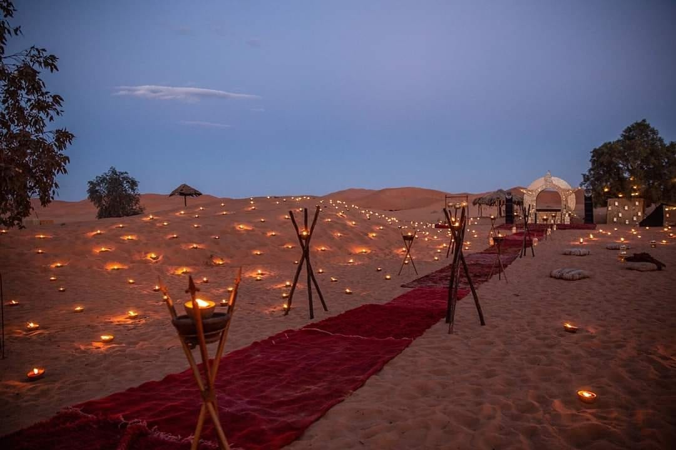

Add Moroccan Experiences to Your Wedding Celebration
One of the most magical aspects of getting married in Marrakech is the opportunity to create unforgettable cultural experiences for your guests.
Many couples incorporate:
- Gnawa musicians,
- traditional Moroccan dancers,
- henna experiences,
- camel arrivals,
- desert dinners,
- fire shows,
- Moroccan tea ceremonies,
- artisan workshops,
- or live oriental music.
These experiences create emotional memories while keeping the celebration authentic and immersive.
The key is balance: blending elegance and luxury with the soul and beauty of Moroccan culture.

Have a Backup Plan for Outdoor Weddings
Outdoor weddings in Marrakech are breathtaking — but planning responsibly is essential.
Depending on the season, temperatures, wind, or occasional rain can impact the celebration. A professional wedding planner will always anticipate:
- weather contingencies,
- technical issues,
- guest comfort,
- lighting changes,
- and logistical transitions between spaces.
Having a well-designed Plan B ensures that the wedding remains elegant and stress-free no matter the circumstances.

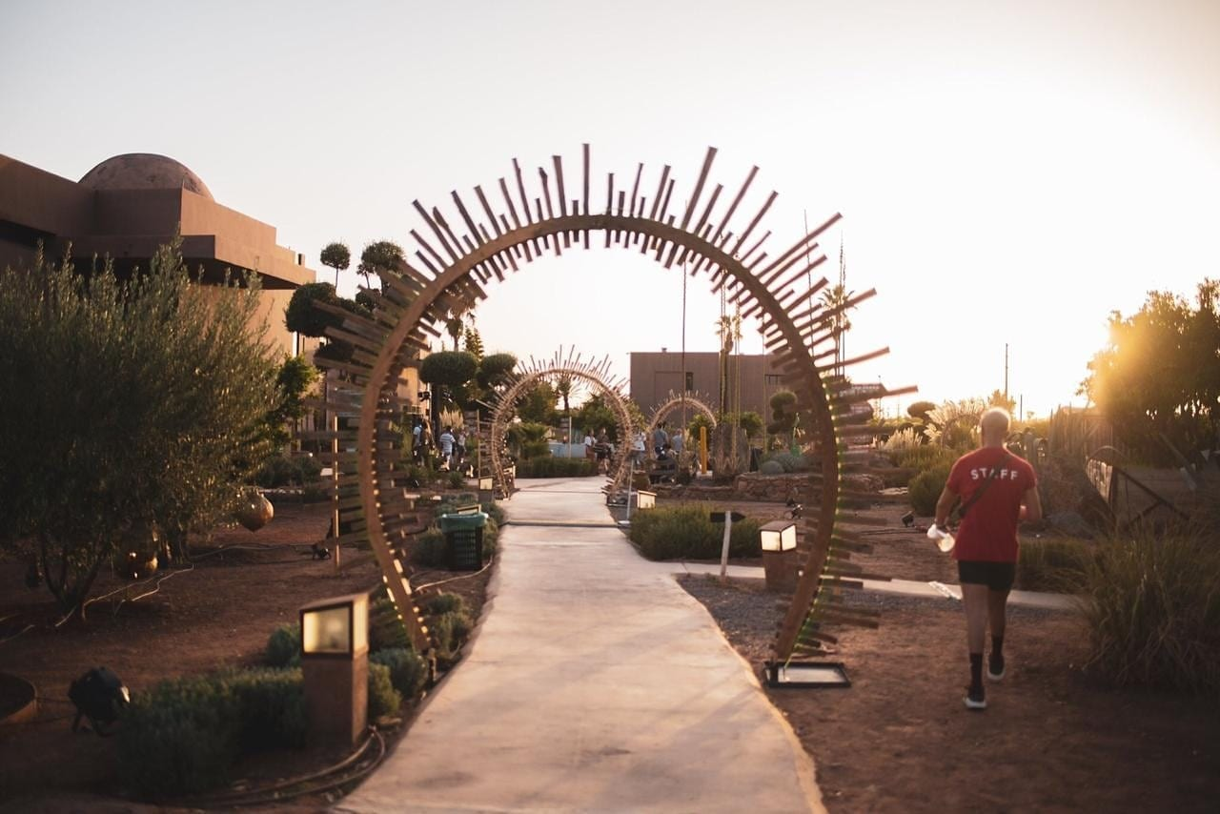

Why Hire a Wedding Planner in Marrakech?
Planning a destination wedding remotely can quickly become overwhelming without local support.
A luxury wedding planner in Marrakech helps you:
- save time,
- avoid costly mistakes,
- access trusted vendors,
- negotiate professionally,
- manage logistics,
- coordinate timelines,
- communicate with local teams,
- and transform your vision into a seamless experience.
Most importantly, it allows you to fully enjoy the journey and focus on the emotional side of your wedding instead of the stress behind the scenes.
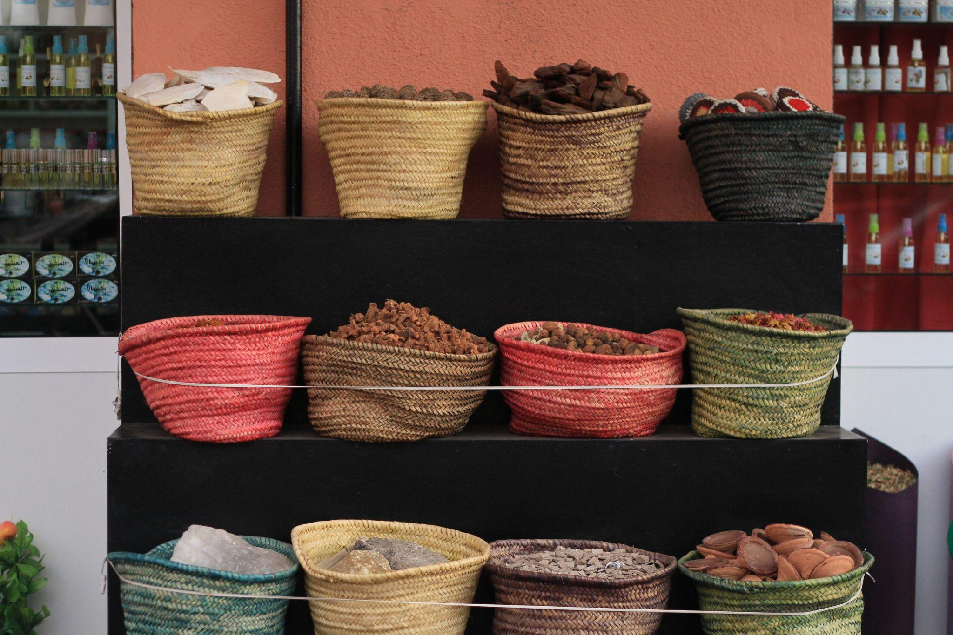

Create Your Dream Wedding in Marrakech
Marrakech is more than a wedding destination — it is an experience filled with beauty, emotion, culture, and unforgettable memories.
Whether you are dreaming of:
- an intimate elopement,
- a luxury destination wedding,
- a multi-day Indian wedding,
- or a romantic celebration under the Moroccan stars,
the Red City offers endless possibilities for creating something truly extraordinary.
At Marrakech Proposal, we specialize in designing elegant, emotional, and immersive celebrations tailored to every couple’s vision.
From venue scouting to full wedding coordination, guest experiences, décor, entertainment, and production — we take care of every detail so you can fully enjoy your moment.

Ready to Start Planning Your Wedding in Marrakech?
Let’s create an unforgettable celebration together.

You may also like :

Tab 2

